Entrant student applying for accommodation
Go to Welcome (st-andrews.ac.uk)
Click on Register
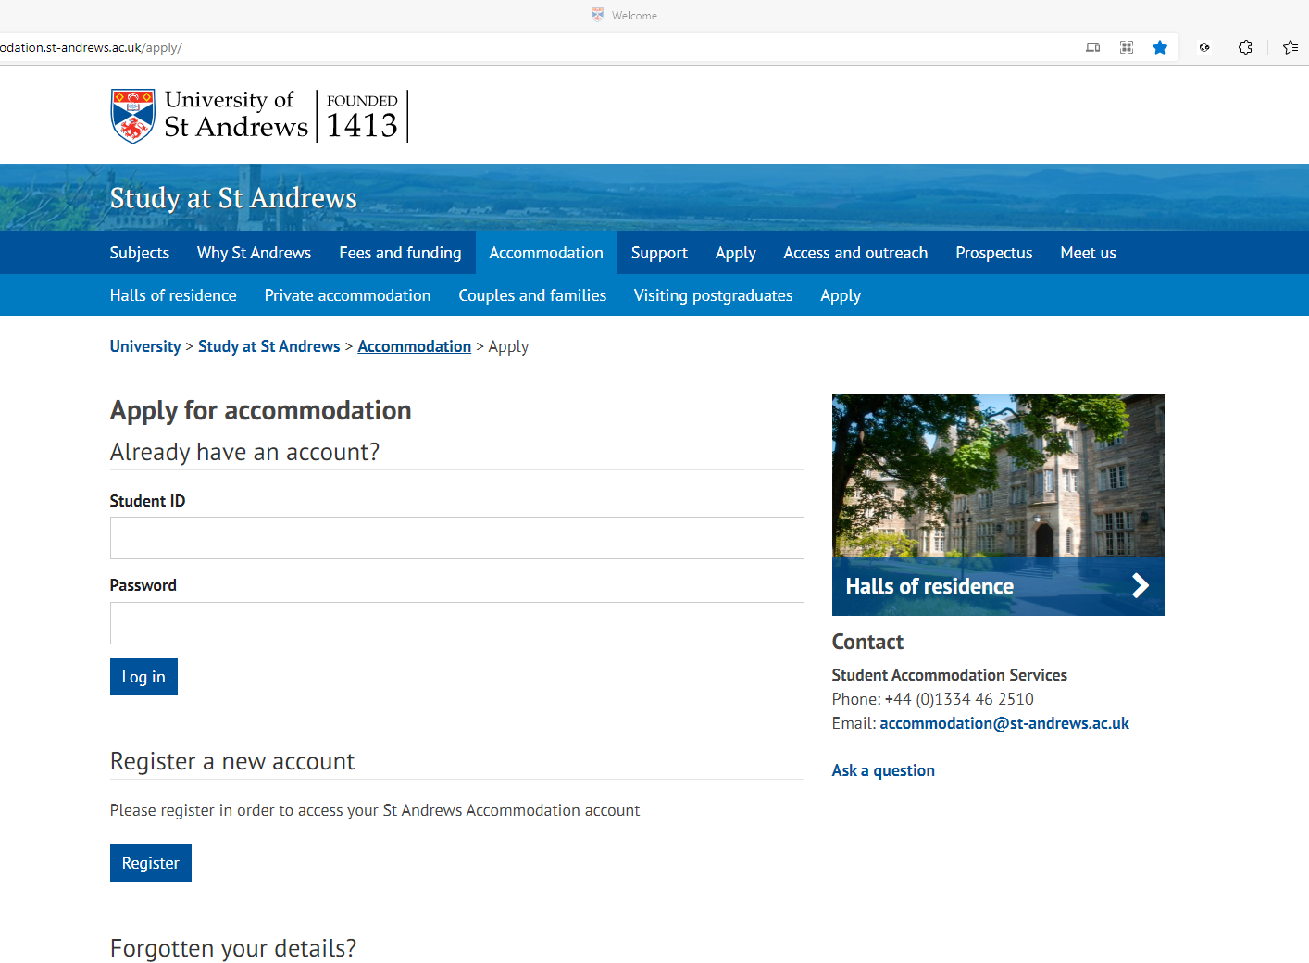

Type in your Surname, date of birth and 9 digit Student ID number
Press Validate details
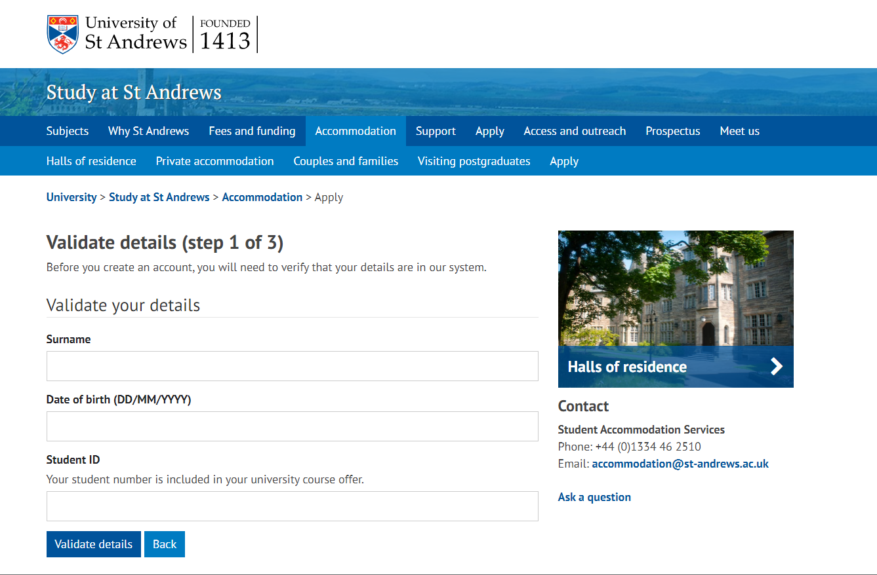
Type in a password and confirm, press create account

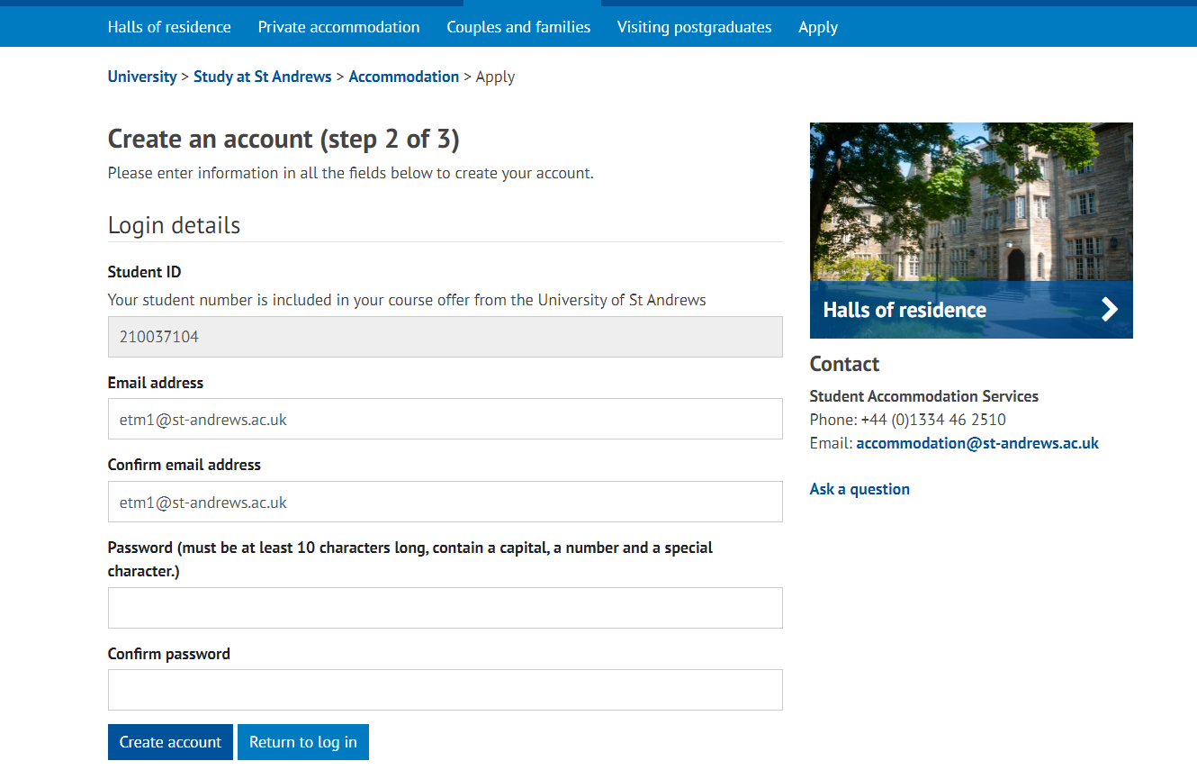

Click on Back to login
Check email and click on link

Complete registration by Confirm code

Click continue

Type in Student ID and the password you made when you created the account and click Log in
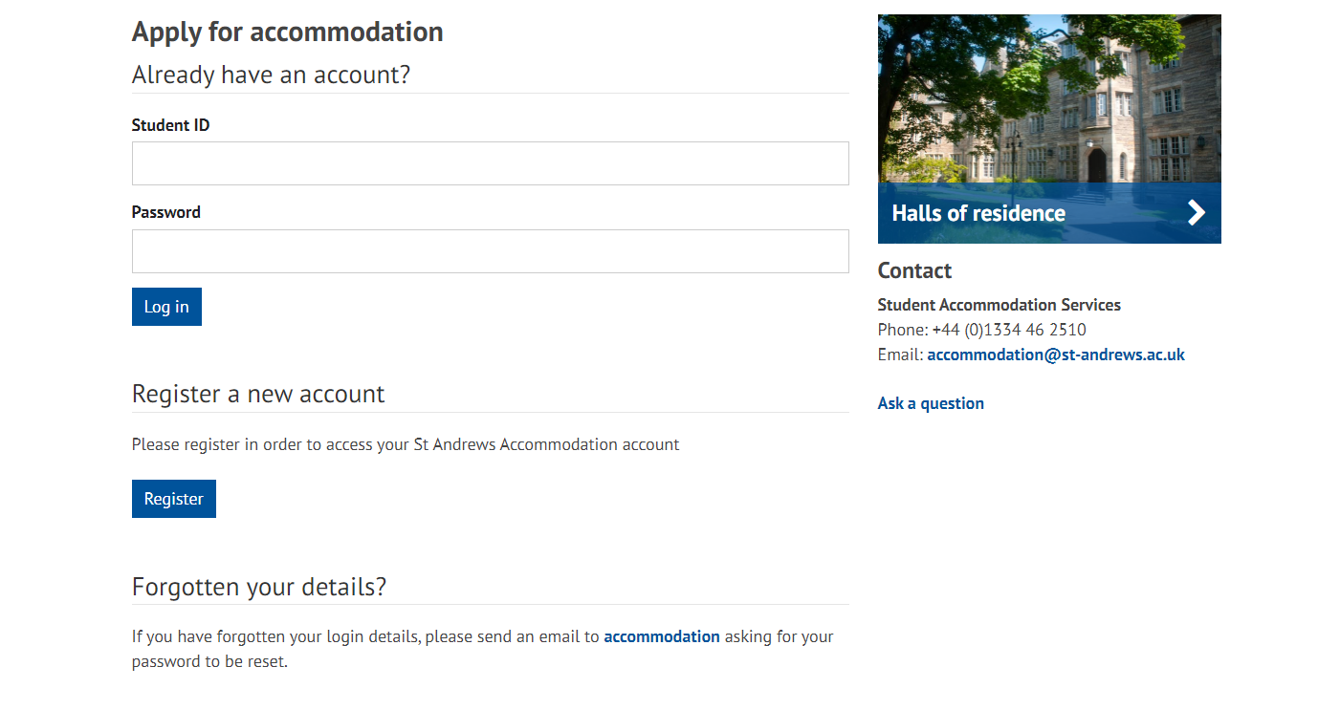
You will need to upload a photo, then click on 2022-23 Your Application
2022-23

Choose 4 different types of accommodation and click on I acknowledge and accept that the University of St Andrews cannot guarantee these accommodation choices
2022-23

Complete the Further preference options then click continue
2022-23

Then complete additional information and click continue
2022-23
Check application summary and press Confirm application
Click return to hub
2022-23

Application now completed and has a green tick, log out
2022-23

